Math Gladiator

By

Raffi Kudlac & Bryce Paterson

1. Overview

The goal of our game is to teach basic mathematical skills to our users who we intend to age anywhere from 4 to about 13. We hope to accomplish this through a series of interactive levels where users will participate in a turn based combat with the computer. Answering correct math questions in shorter amounts of time will result in higher damage to the opponent. We anticipate that our audience will find this style of answering math questions engaging.

2. Game Screenshots

2.1. Splash Screen

Below is a image of our current splash screen. It’s purpose is to simply introduce the name of the game and 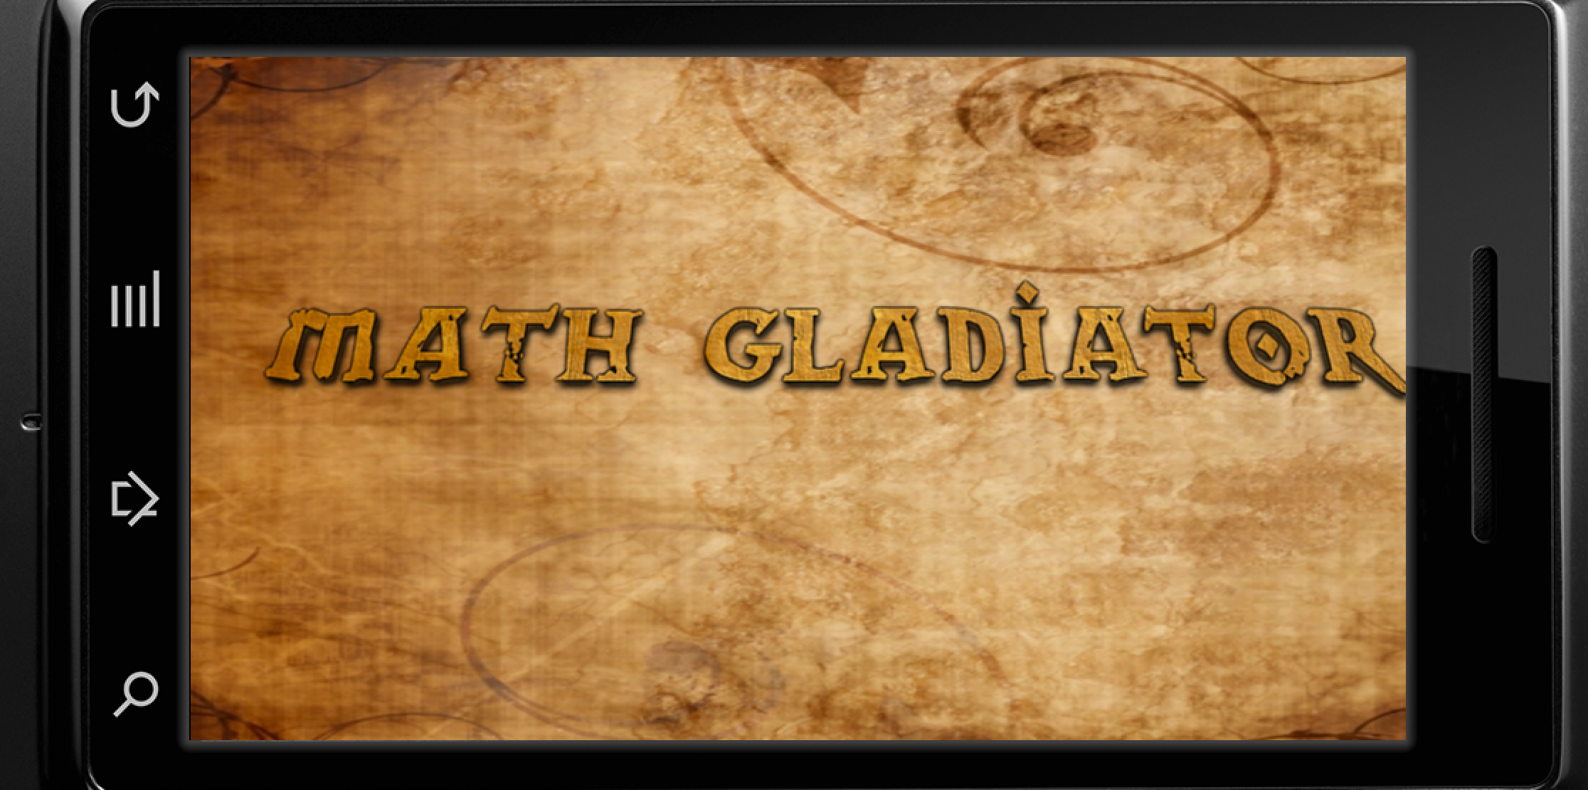promote excitement for the upcoming events.

(figure 1)

2.2. Menu Screen

Below is an image of our games main menu page, from here, users will be able to access all features of the game. All pieces of text are pretty self explanatory, all the 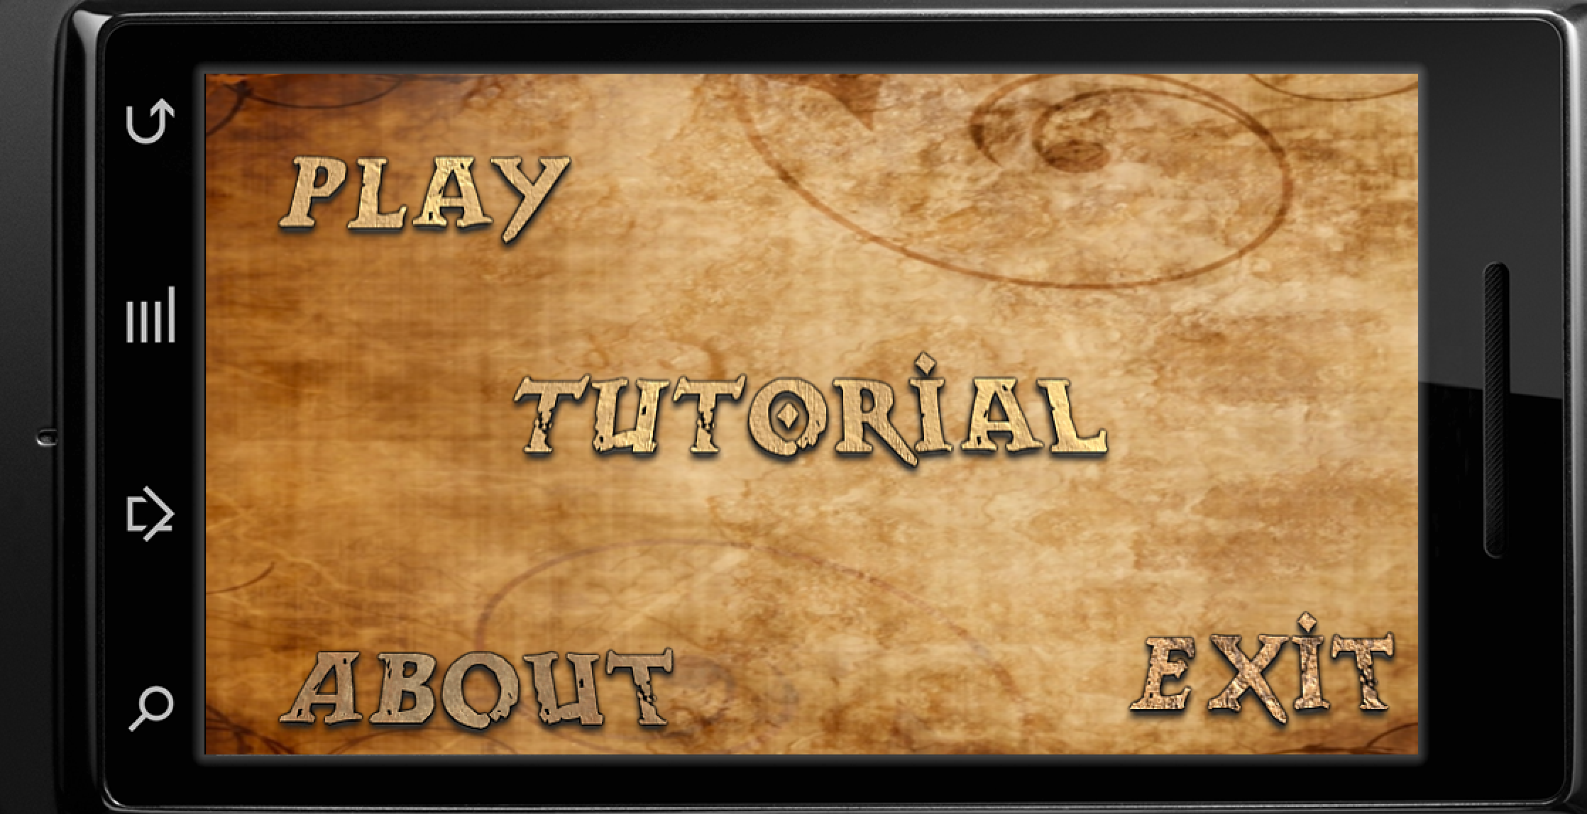user has to do to is select one to pursue that option.

(figure 2)

2.3. Credits Screen

Below is an image of our credits page. Here is where the users will go to see information about the game, who it was made by and any sources that need 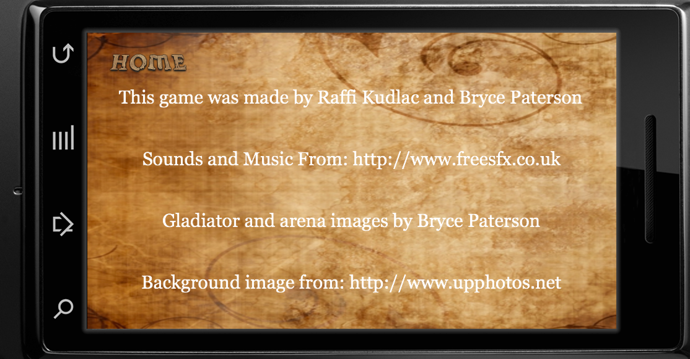acknowledgement for their contributions to the game.

(figure 3)

2.4. Tutorial Screen

Our tutorial screen currently covers a very basic overview of our game . Explaining the users objectives, informing them how to reach them and the simple layout of 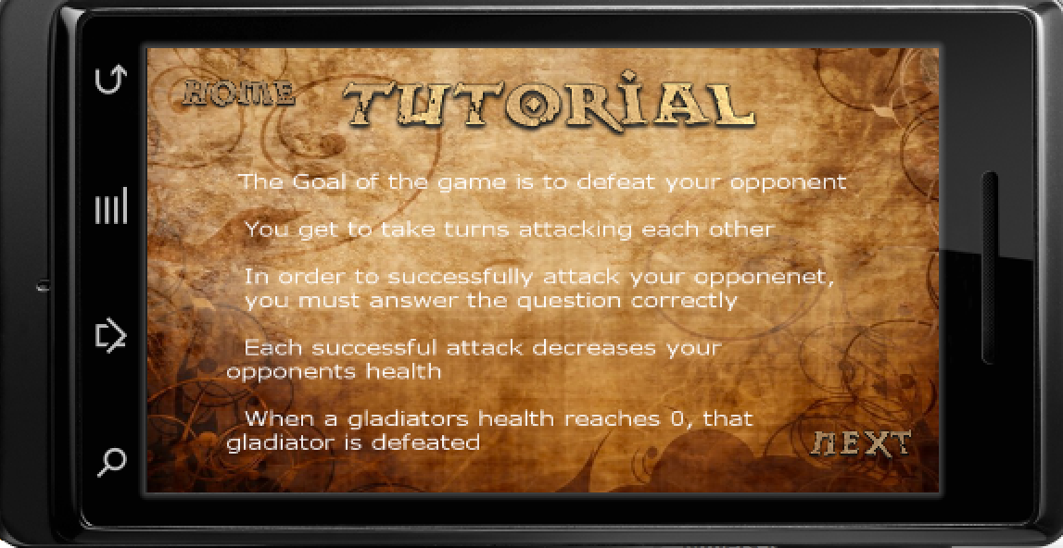the game.

(figure 4)

2.5. Consent Screen

Upon the users first use of the app the user is asked permission if we can record their experience of our app and learn from it. The Users response is saved to a text file and 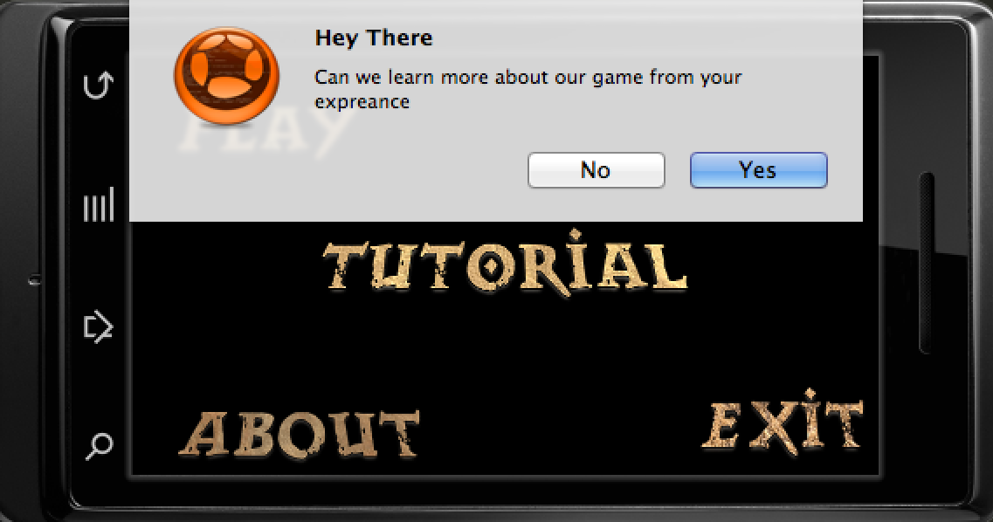the file is read every time the app is opened.

(figure 5)

2.6. Level Screen

Here is the level screen where the user can pick what kind of math questions he/she would like to face and of what difficulty. Right now users can only select addition. Users will also initially have to defeat one level to unlock the next. For testing purposes, all the levels in the screen shot are 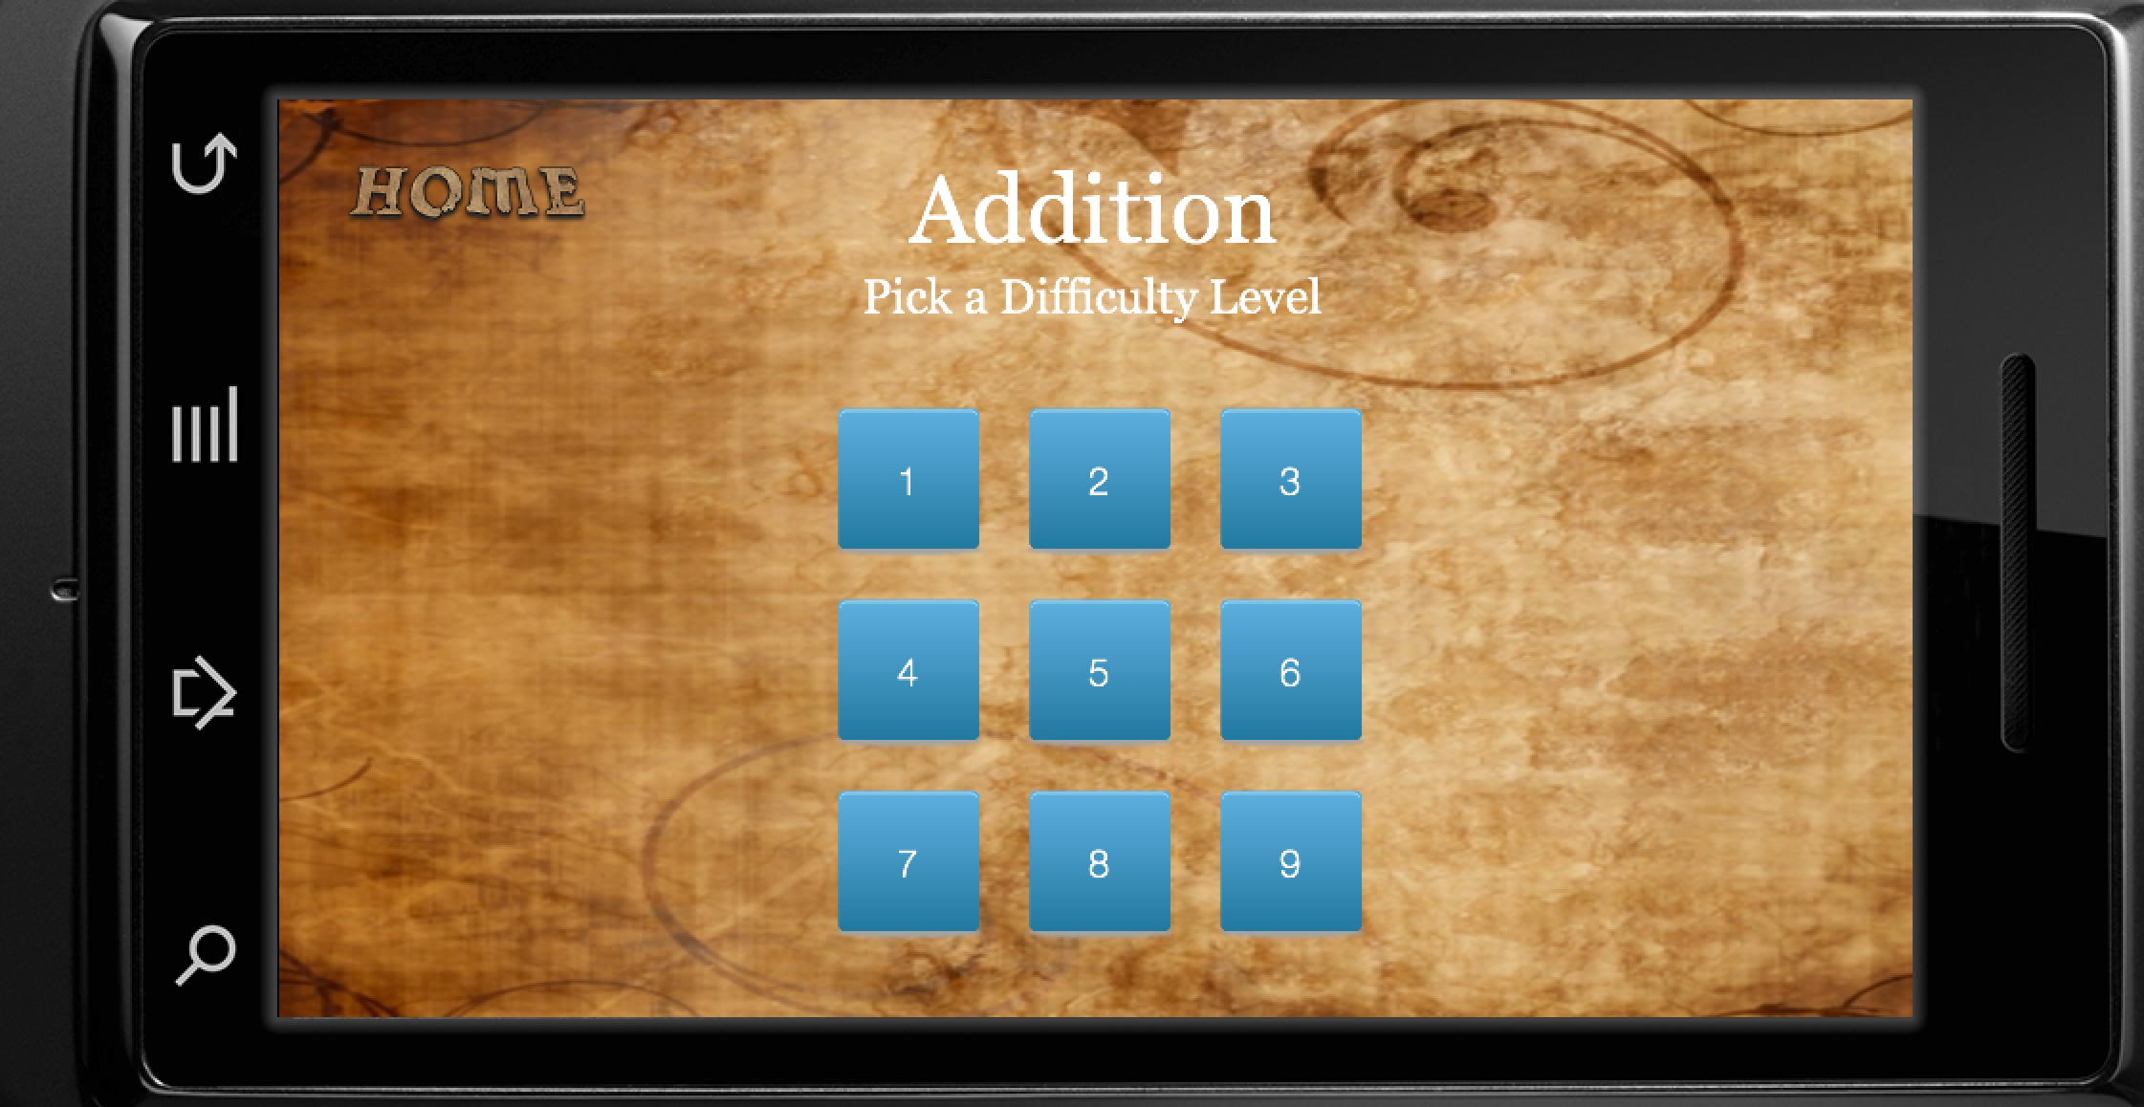unlocked.

(figure 6)

2.7. Game Play Screen

Below is the game play screen at its basic level. The players health is represented by fractions in the top left and right corners, the computer in the right and player in the left (see figure 7). Questions appear at the top of the screen and the user enters the answer in the calculator. If the answer 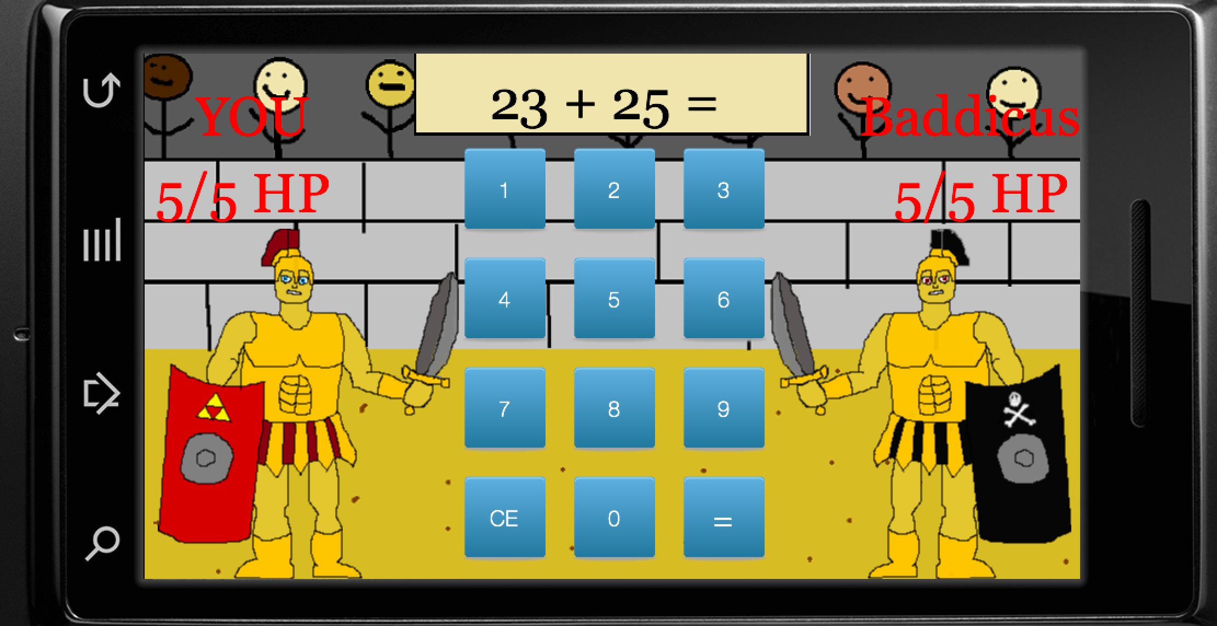is correct then damage is dealt to the computer (see figure 8).

(figure 7)

If the answer is incorrect then no damage is done. After each players turn the computer takes a turn as well. The capability of the computer getting a problem right is calculated through probability. The higher level the user is at the higher chance the computer will do damage. Figure 8 shows a case where 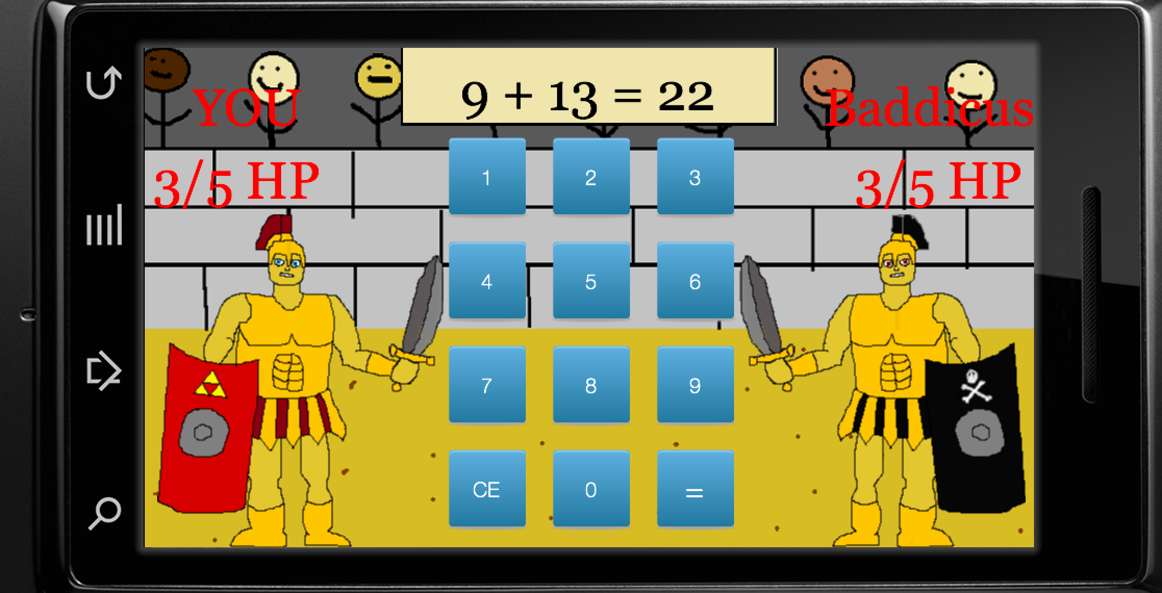the computer has had two successful attacks.

(figure 8)

3. Intellectual Property

All image and sound file were either created by the designers, or downloaded from online open source libraries on the condition that they by properly cited. All files downloaded are cited both here and in the ‘about’ section of the game’s menu.

3.1. Image Files

The battle arena and gladiator images were created by Bryce Paterson using Microsoft Paint and GIMP, two image creation and processing softwares. The other images include the blue box images in the level screen, the menu background image, and the menu text images which were downloaded from (respectively):

<http://www.iconarchive.com/show/pretty-office-9-icons-by-custom-icon-design/square-icon.html>

<http://www.upphotos.net/>

<http://textcraft.net/>

3.2. Sound Files

All sound files were downloaded in mp3 format from the following online open source sound library:

http://textcraft.net/

4. Design Rationale

The overall design rationale of Math Gladiator, was that in order to make a game educational it must function as a game first, and be educational second. That is to say we opted for a fun game that happened to be educational, rather than education in the form of a game. The inspiration for the game model of a ‘turn-based combat game’, came from our experience playing existing games. We noticed that turn based-combat games are very common, generally very fun (and sometimes best-sellers), as well as requiring minimal animations and artwork. Given our initial notion of fun followed by educational, it seemed like a turn-based combat type game would fit our needs well.

4.1 Rationale for better UI design

We found that most of the math games we played and analyzed before had very intuitive and simple user interfaces, as they were developed for use by children in the first place. We tried to implement some of the patterns we saw in the UI of other games to ensure that our game’s UI was at least as good.

One such pattern was simplicity. We kept our UI as simple as possible in three ways: few functions, clear controls, little variation. Our game is all about the battle between the two gladiators, so very few functions we needed to achieve this goal. Other than the ‘about’, ‘tutorial’, and ‘about’ buttons, the only other functions are the basic calculator buttons.

Another pattern we employed was interesting aesthetics. The aesthetics of our game were greatly influenced by the gladiator theme of the game. The background image and text for the splash page, and menu pages was kept in line with this theme to give it an interesting, and appealing flavor. In the battle part of the game, we tried to create interesting character drawings and background, as well as bright, clear colours for the buttons and player descriptions.

A third pattern found in good user interfaces we tried to employ was little variation. We tried to make as few variations of the UI as possible to make it easier to learn. In fact there are no variations to the UI of our game. There is only one concept to be mastered, while still being an interesting game.

In summary, our game’s UI is both simple to use and aesthetically pleasing. The images and themes are appropriate for all ages, while the controls are very intuitive. This allows users of all ages to begin playing the game without reading the tutorial, although one is provided to them should they wish it.

4.2. Rationale for better Pedagogy

In the games we played an analyzed before it was found that most of the games followed a simple drill and practice method. Although ours employs the same method, it achieves a better pedagogy in the following way:

**1. Better Feedback:** Math Gladiator not only tells you if you are right or wrong, but it also tells the player what the correct answer was in the case where the player was wrong. This is something that was not found in the other games.

**2. Gives Examples:** Math Gladiator game allows you to see the opposing, computer player’s question and then after a moment the computer players answer. The corresponding miss and hit sounds allow the player to learn from the opponents mistakes, at no penalty to them.

**3. Clearer Assessment:** Math Gladiator gives the player a very clear way of assessing their performance, whether or not they defeated the opponent, and what the final ‘score’ was, meaning how much health they had at the end of the game.

**4. Elicits Performance:** Math Gladiator is competitive by nature. It does a better job of eliciting performance because it simulates a direct challenge. It requires the opponent to complete the same challenge. It also gives the player a specific obstacle to overcome at each level.

**5. More Difficulty Levels:** Math Gladiator has more difficulty levels than the other games. There are 9 difficulty levels, each of which increases the difficulty of the questions, or the proficiency of the opponent. This leads to a smoother learning curve, with more steps increasing difficulty in smaller increments.

5. Proposed Data Log

5.1. Questions to Address

Aspects of our game that we are interested directly revolve around the users experience. We want to know

1. how far the average user progresses through the game for each mathematical operation (addition, subtraction ect).
2. if we set appropriate difficult levels.
3. if users us the tutorial or if they just dive in.
4. if users found the app entertaining

5.2. Data to Collect

In order to answer question 1 from the previous section all we would have to do is record the level the user made it to for each section. Question 2 is much more demanding requiring the number of questions asked in each level in each section and recording how many were right and wrong. We would also record the total time spent on each section. This will the rate of change between right and wrong answers as the levels increase. Question 3 merely requires the logging of a click of the tutorial button. Question 4 requires the logging of time spent on the app. This is just a sum on the time recorded for question 2. In theory, if users spend large amounts of time using the app they will enjoy it.